Pre-EV Charge Point Information
Please note that OLEV claims MUST be submitted by the individual to whom the vehicle is registered
Customer Information
Name
Address
Postcode
Phone
Email
Vehicle and charge point
Make
Model
Charger type 1/2
Tethered/ un-tethered
Lead length
If vehicle in your possession
Registration number
VIN number
Proof of ownership, or V5 document | Please provide a copy on day of installation, or original to be scanned
Car registered to: (name as printed on V5)
Confirm you took possession of vehicle after 1st October 2016
Vehicle (if on order)
Expected delivery date
One of:
Order number, Agreement number, Enquiry number, Arrangement number Enquiry number
Company car
If this is a company car, please use link to right to access document and forward to relevant person/ department in your organisation | www.hardingelectriccompany.com/reference
Your property
Do you have any other EV charge points already?
Confirm you have dedicated private parking
MPAN reference. 21-digit reference from your electricity bill – usually appears as below
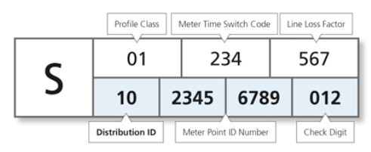

Privacy Policy
OLEV grant claims contain personal data. Please ensure to open and read the privacy policies, on the links attached | https://www.hardingelectriccompany.com/privacy  www.gov.uk/olev/privacy-policy

